**SYSTEM / OPERATION & USER MANUAL**

**FOR**

**Development of I&T Project**

**Management Information System (INTPMIS)**

**OF**

**Electrical and Mechanical Services Department**

Version: 0.1

**August 2020**

© The Government of the Hong Kong Special Administrative Region

The contents of this document remain the property of and may not be reproduced in whole or in part without the express permission of the Government of the HKSAR

| **Distribution** | |
| --- | --- |
| Copy No. | Holder |
| 1 |  |
| 2 | Master Concept (Hong Kong) Limited |

| Prepared By:  Derek Chan  [Programme Manager, MCHK] | Endorsed By:    [ ] |
| --- | --- |
| Date: 26/Aug/2020 | Date: dd/mm/2020 |

| **Amendment History** | | | | | |
| --- | --- | --- | --- | --- | --- |
| Change Number | Revision Description | Pages Affected on Respective Version | Revision / Version Number | Date | Approval Reference |
| 1 | Initial Version | All | 1.0 | 26 Aug 2020 |  |
|  |  |  |  |  |  |
|  |  |  |  |  |  |
|  |  |  |  |  |  |
|  |  |  |  |  |  |
|  |  |  |  |  |  |
|  |  |  |  |  |  |
|  |  |  |  |  |  |

Table of Contents

***Introduction 3***

**Program Specifications 3**

Functional Requirements 3

Non-functional Requirements 5

Use Case or Scenarios 6

User Interface (UI) Design 16

System Architecture 25

**Training manual and material 27**

***System & Programming Manual and Workflow 28***

**User Login 28**

**Database Structure 29**

**System structure 30**

**Website Layout 30**

**API from innoportal CMS 31**

Solution import 31

Wish import 32

**INTPMIS Report 33**

Trend of I&T Wishes, Solutions, and Matched Trial Projects Report 34

Summary of I&T Wishes Report 34

Distribution of I&T Solutions by Technology Report 35

Cash flow for Matched Trial Projects on E&M InnoPortal Report 35

Statistics on I&T Projects Report 36

Statistics Technology on I&T Projects Report 37

Expenditure on I&T Projects Report 37

***Users Procedures and Operation Manual 38***

**Login to INTPMIS 38**

**Project 39**

Browsing Project List 39

Create a Project 41

Edit a Project 43

**Wish List 45**

Browsing Wish List 45

Edit a Wish 47

**Solution List 48**

Browsing Solution List 48

Edit a Solution 49

***Administrator Procedures and Operation Manual 51***

**Project 51**

Edit a Project 51

**Log List 52**

Browsing Log List 52

# Introduction

This System & User Manual intended to provide the necessary information to use the I&T Project Management Information System (INTPMIS).

The manual assumed that the working environment of the system is under Window10 operation system with IE11 or Chrome browser.

## Program Specifications

### Functional Requirements

1. Login

* The system should support single sign on through the Windows Active Directory
* Support Existing User Permission Matrix Mapping
* If the user is an Acting of another user according to the LDAP login details, there should be an option for the user to choose whether to access the INTPMIS as the role of Acting or the original role of the user

1. Project List

* A page allows users to search for the projects
* Support sorting and filtering
* Allow to export the project list result in file type ".csv" in the Project page
* Allow to configure the filtering and sorting criteria
* Allow to view / edit project

1. Create a Project

* Allow users to create a project

1. View or Edit a Project

* Support read-only and edit mode the permission of the user

1. Wish List

* A page allows users to search for the wishes
* Support sorting and filtering
* Allow to export the wish list result in file type ".csv" in the Wish page
* Allow to configure the filtering and sorting criteria
* Allow to view / edit wish

1. View or Edit a Wish

* Support read-only and edit mode the permission of the user

1. Solution List

* A page allows users to search for the solutions
* Support sorting and filtering
* Allow to export the solution list result in file type ".csv" in the Solution page
* Allow to configure the filtering and sorting criteria
* Allow to view / edit solution

1. View and Edit a Solution

* Support read-only and edit mode the permission of the user

1. Report List

* Support sorting and filtering
* Allow to export the report list result in file type ".csv" in the Report page
* Allow to configure the filtering and sorting criteria
* Allow to view / edit report

1. View Report

* Support read-only mode the permission of the user

1. Log List

* Support sorting and filtering
* Allow to export the log list result in file type ".csv" in the Report page
* Allow to configure the filtering and sorting criteria
* Allow to view / edit log

1. View Log List

* Support read-only mode the permission of the user

1. Upload File

* Allow users to upload multiple formats of files, such as pdf, jpeg, docx, xls
* Users can replace the files
* The files can be deleted

### Non-functional Requirements

1. Response Time

* The response time for predefined query should be 95% within 5 seconds, subject to confirmation of the selected technical solution.

1. Service Time

* The access to the new system would be 08:00 to 20:00 daily, and late night provisionally. 7x24 availability is not required.
* Achieve availability of 99.0% (i.e. unscheduled downtime could not exceed 7.2 minutes per day or 1.83 days per year on average).

1. Export

* Allow data of tables to be exported in different external easy-readable formats such as Excel.

1. Scalability

* Provide scalability options of hardware, software, etc. for future system expansion.

1. System Performance

* Provide technically sound architecture to meet response time and agreed performance level.

1. User Interface Requirement

* The user-interfaces and graphical user interface (GUI) must be user-friendly. Based on the user profile, personalised views can be provided. The interface of the solution should be consistent with web-based applications.
* Adopt responsive web design to adjust layout according to different screen sizes in order to facilitate users’ browsing experience in devices including but not limited to desktops, tablets and mobile phones.
* Function and display properly in multiple browsers including Internet Explorer and Chrome with Apollo support version.

1. Function Access Rights

* Able to define various user access rights of functions according to operations or user levels (access right can be assigned to the user group or individual user).

1. Access to Data

* Able to define access rights for users to access particular data and also on a conditional basis.
* Able to define access monitoring for the selected data.

1. System Backup

* Able to meet general backup requirements including data and system; and all audit logging information.

### Use Case or Scenarios

| Use Case | SSO Login |
| --- | --- |
| Actor | User |
| Description | This use case describes the steps involved in a user logging into the INTPMIS |
| Preconditions | The user has an account with the application |
| Main Scenario | * User gets an authentication ID from EMSD Active Directory * The system will call LDAP API to get users authentication code and information by the staff ID |
| Postconditions | The landing page will be shown |
| Alternative Scenario | The user name login page will be shown |

| Use Case | User Name Login |
| --- | --- |
| Actor | User |
| Description | This use case describes the steps involved in a user logging into the INTPMIS |
| Preconditions | The user has an account with the application |
| Main Scenario | * Open a browser (Internet Explorer/ Chrome) * Go to http://intpmis/#/login * Input email address and password * Click "Sign In" button |
| Postconditions | The page is navigated to the landing page |
| Alternative Scenario | Login fail and an error prompt is shown. |

| Use Case | Create Project |
| --- | --- |
| Actor | User |
| Description | This use case describes the steps involved in a user creating a new project in the project management |
| Preconditions | * The user is logged into the application. * The user has the necessary permissions to create a project. |
| Main Scenario | * Click “Create” under “Project Management” * Fill the required fields * Click “Submit” button |
| Postconditions | Project is created successfully and a successful message is shown with the project number |
| Alternative Scenario | 1. Input field is not filled   The error message is shown under the field   1. Value is not valid   The error message is shown |

| Use Case | Edit Project |
| --- | --- |
| Actor | User |
| Description | This use case describes the steps involved in a user editing an existing project in the project management. |
| Preconditions | * The user is logged into the application. * The user has the necessary permissions to create a project. |
| Main Scenario | * Click “Edit” under “Project Management” * Click edit icon to edit the project * To edit information of the project, users can:   + select completed   + input values   + empty input * Then click “Save All” button |
| Postconditions | Save successfully and an successful message is shown |
| Alternative Scenario | Invalid input and an alert message is shown |

| Use Case | View Project |
| --- | --- |
| Actor | User |
| Description | This use case describes the steps involved in a user viewing the details of an existing project in the project management. |
| Preconditions | * The user is logged into the application. * The user has access to the project they want to view |
| Main Scenario | * Click “View” under “Project Management” * Scroll the bottom bar to the right to show the project detail |
| Postconditions | The user has viewed the details of the selected project. |

| Use Case | Filter Project |
| --- | --- |
| Actor | User |
| Description | This use case describes the steps involved in a user filtering for specific projects within the project management. |
| Preconditions | * The user is logged into the application. * The user is on the project management list displaying a list of projects. |
| Main Scenario | * Input filter value * Select display number of record per page |
| Postconditions | The results are shown |

| Use Case | Search Project |
| --- | --- |
| Actor | User |
| Description | This use case describes the steps involved in a user searching for a specific project within the project management. |
| Preconditions | * The user is logged into the application. * The user is on the project management list displaying a list of projects. |
| Main Scenario | * Click search section * Select search criteria * Select values of criteria * Click “Search” button |
| Postconditions | The results are shown |

| Use Case | Export Project |
| --- | --- |
| Actor | User |
| Description | This use case describes the steps involved in a user exporting project data from the project management. |
| Preconditions | * The user is logged into the application. * The user is on the project management list displaying a list of projects. |
| Main Scenario | There are two options for exporting project   * Export searched records   Click “Export Records” button   * Export all records   Click “Export All Records” button |
| Postconditions | The exported results will be stored in a csv file |

| Use Case | Edit Wish |
| --- | --- |
| Actor | User |
| Description | This use case describes the steps involved in a user editing the details of an existing wish in the wish management. |
| Preconditions | * The user is logged into the application * The user has access to the wish they want to edit |
| Main Scenario | * Input value to edit * Click “Save All” button |
| Postconditions | Wish is edited successfully and an alert message is shown |
| Alternative Scenario | Invalid input and an alert message is shown |

| Use Case | View Wish |
| --- | --- |
| Actor | User |
| Description | This use case describes the steps involved in a user viewing the details of an existing wish in the wish management. |
| Preconditions | * The user is logged into the application * The user has access to the wish they want to view |
| Main Scenario | * Click “View” under “Wish Management” * Scroll the bottom bar to right to view detail of the wish |
| Postconditions | The user has viewed the details of the selected wish. |

| Use Case | Search Wish |
| --- | --- |
| Actor | User |
| Description | This use case describes the steps involved in a user searching for a specific wish within the project management. |
| Preconditions | * The user is logged into the application. * The user is on the wish management list displaying a list of wishes. |
| Main Scenario | * Click search section * Select search criteria * Select values of criteria * Click “Search” button |
| Postconditions | The results are shown |

| Use Case | Filter Wish |
| --- | --- |
| Actor | User |
| Description | This use case describes the steps involved in a user filtering for a specific wish within the project management. |
| Preconditions | * The user is logged into the application. * The user is on the wish management list displaying a list of wishes. |
| Main Scenario | * Input filter value * Select display number of record per page |
| Postconditions | The results are shown |

| Use Case | Export Wish |
| --- | --- |
| Actor | User |
| Description | This use case describes the steps involved in a user exporting wish data from the wish management. |
| Preconditions | * The user is logged into the application. * The user is on the wish management list displaying a list of wishes. |
| Main Scenario | There are two options for exporting wish   * Export searched records   Click “Export Records” button   * Export all records   Click “Export All Records” button |
| Postconditions | The exported results will be stored in a csv file |

| Use Case | Edit Solution |
| --- | --- |
| Actor | User |
| Description | This use case describes the steps involved in a user editing the details of an existing solution in solution management. |
| Preconditions | * The user is logged into the application * The user has access to the solution they want to edit |
| Main Scenario | * Input value to edit * Click “Save All” button |
| Postconditions | Solution is edited successfully and an alert message is shown |
| Alternative Scenario | Invalid input and an alert message is shown |

| Use Case | View Solution |
| --- | --- |
| Actor | User |
| Description | This use case describes the steps involved in a user viewing the details of an existing solution in solution management. |
| Preconditions | * The user is logged into the application * The user has access to the solution they want to view |
| Main Scenario | * Click “View” under “Solution Management” * Scroll the bottom bar to right to view detail of the solution |
| Postconditions | The user has viewed the details of the selected solution. |

| Use Case | Export Solution |
| --- | --- |
| Actor | User |
| Description | This use case describes the steps involved in a user exporting solution data from the solution management. |
| Preconditions | * The user is logged into the application. * The user is on the solution management list displaying a list of wishes. |
| Main Scenario | There are two options for exporting solution   * Export searched records   Click “Export Records” button   * Export all records   Click “Export All Records” button |
| Postconditions | The exported results will be stored in a csv file |

| Use Case | View Report |
| --- | --- |
| Actor | User |
| Description | This use case describes the steps involved in a user viewing reports in report management. |
| Preconditions | * The user is logged into the application |
| Main Scenario | * Click “View” under “Report Management” * Scroll down to view more reports |
| Postconditions | The user has viewed reports. |

| Use Case | Print Report |
| --- | --- |
| Actor | User |
| Description | This use case describes the steps involved in a user printing a report |
| Preconditions | * The user is logged into the application * The user has access to the report they want to print * The report is displayed or accessible on the application's interface |
| Main Scenario | * Select the period of the report * Select the other day for the report * Click “Confirm” button * The report is shown * Click “Print” to print all report |
| Postconditions | * The user has successfully printed the report with the chosen print settings. |

| Use Case | View and Export Log |
| --- | --- |
| Actor | User |
| Description | This use case describes the steps involved in a user viewing and exporting log |
| Preconditions | * The user is logged into the application * The user has access to the logs they want to export |
| Main Scenario | * Select tag type of log * Log records are shown in list * Click “+” button to view log detail * Click “Export Records” button to export records to a csv file |
| Postconditions | The logs are exported to a csv file |

| Use Case | Cancel Reminder |
| --- | --- |
| Actor | User |
| Description | This use case describes the steps involved in a user cancelling a reminder |
| Preconditions | * The user is logged into the application * The user has created a reminder |
| Main Scenario | There are two options to cancel reminder(s):   * Click checked button to cancel the reminder of a record * Select multiple records and click batch checked to cancel reminder of selected records |
| Postconditions | The reminder is cancelled |

### User Interface (UI) Design

1. Login Page

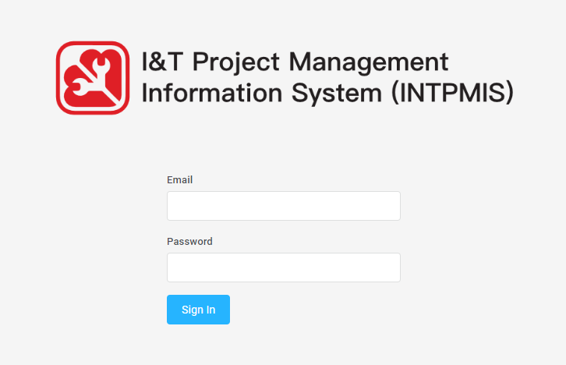

1. Project Management

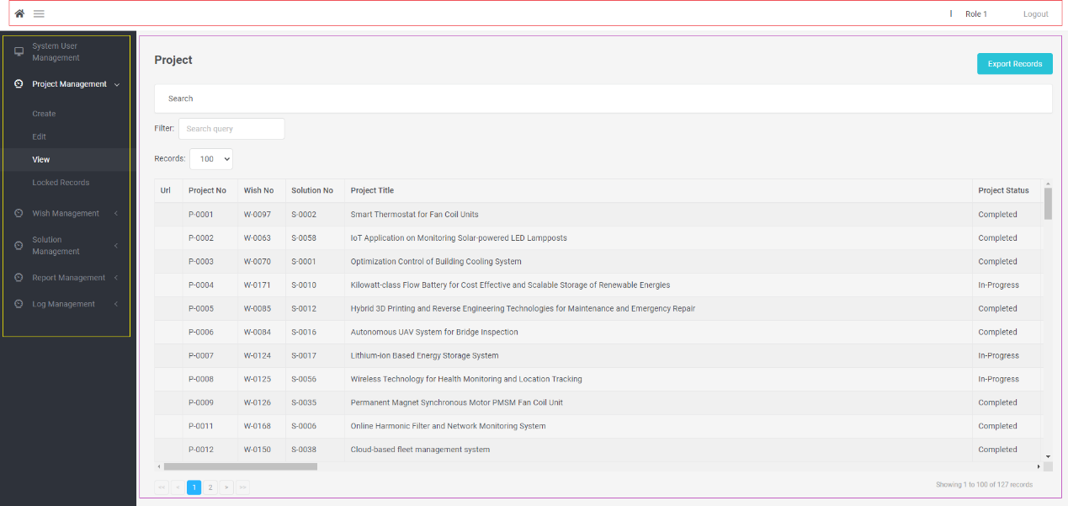

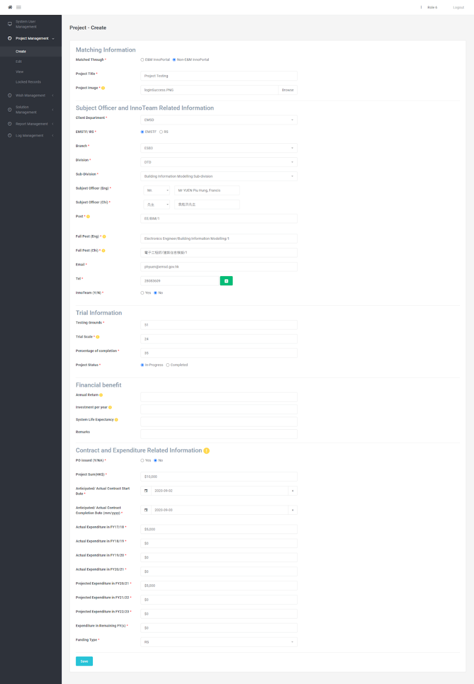

1. Report Management

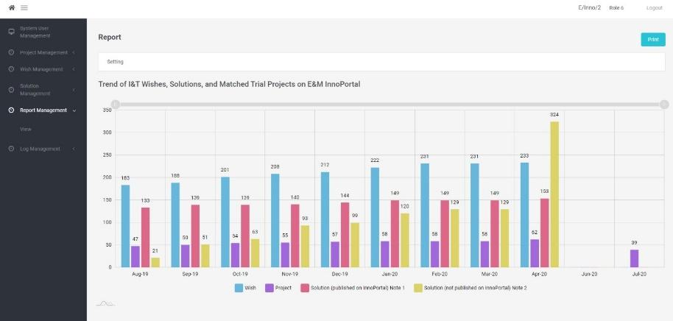

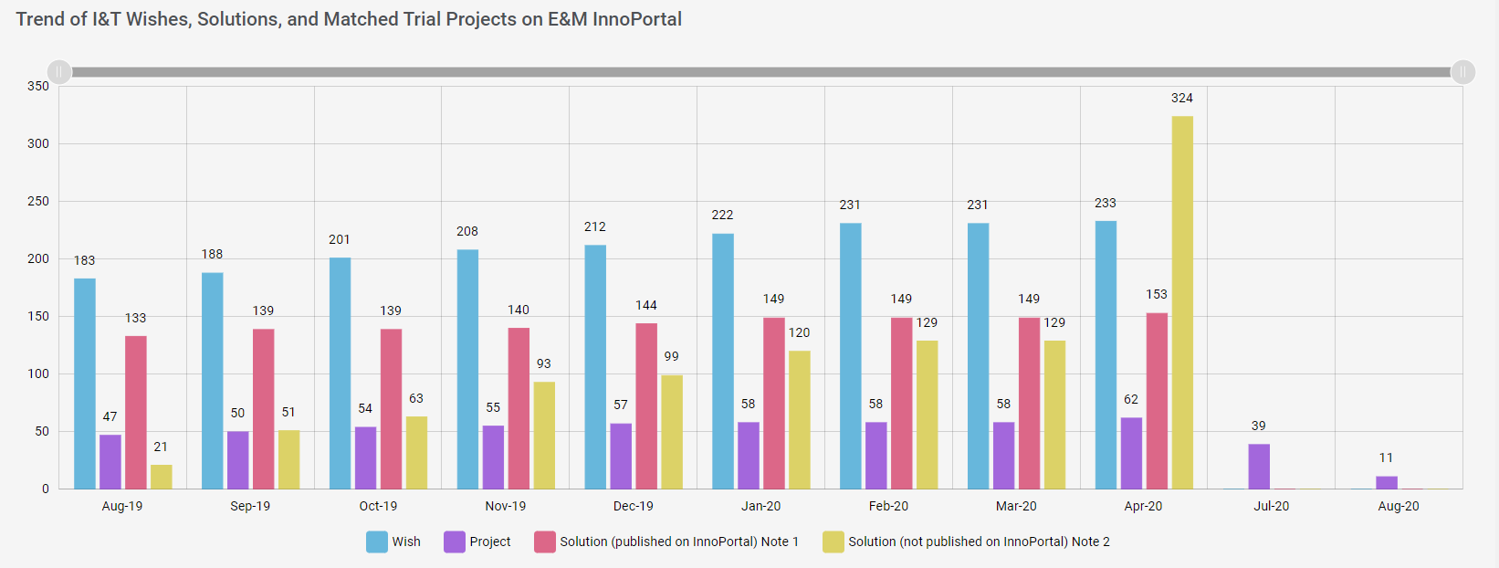

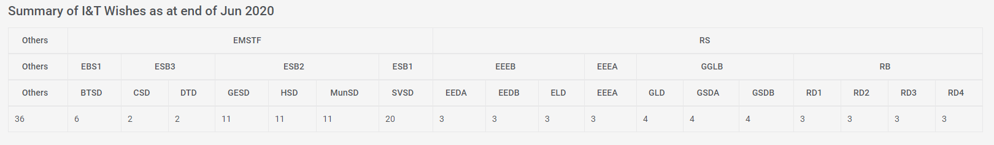

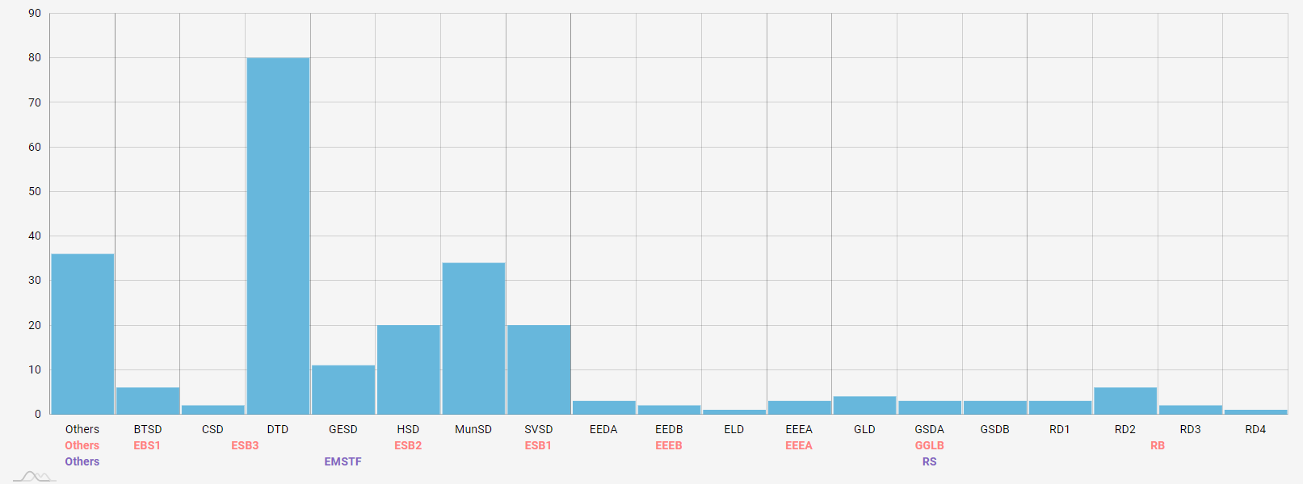

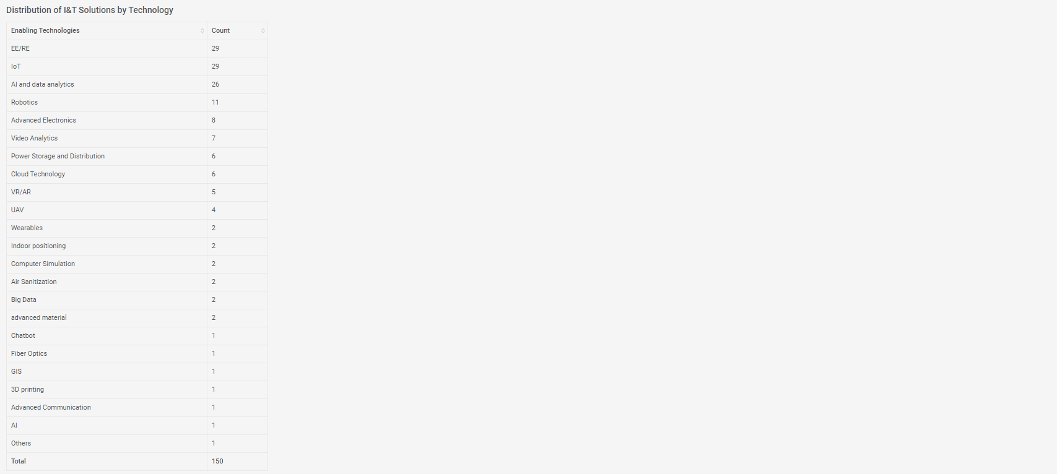

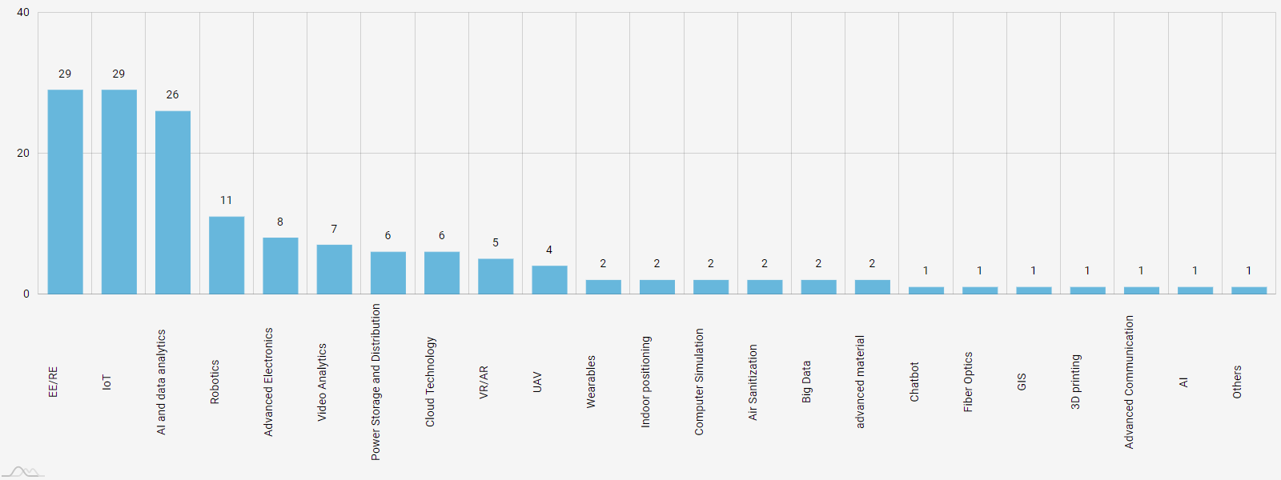

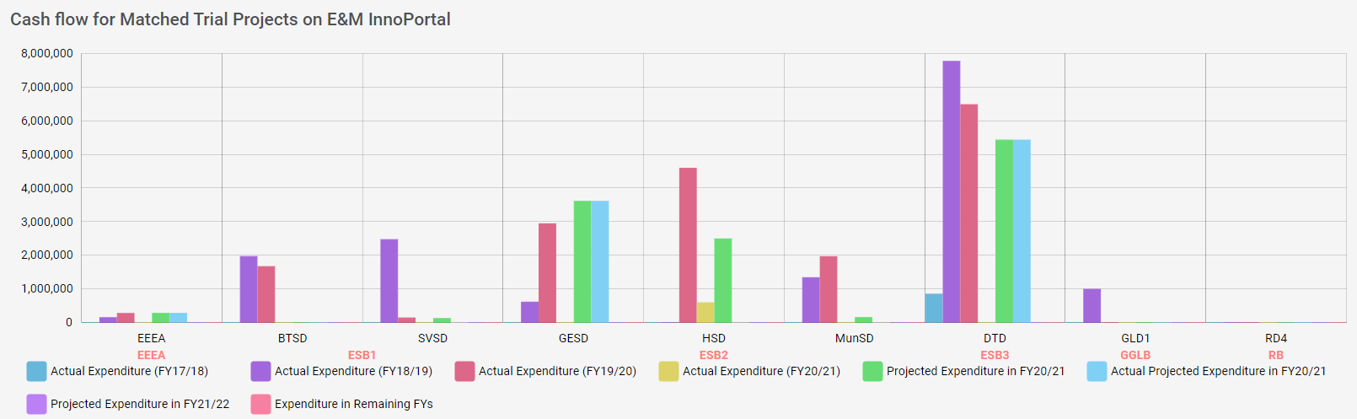

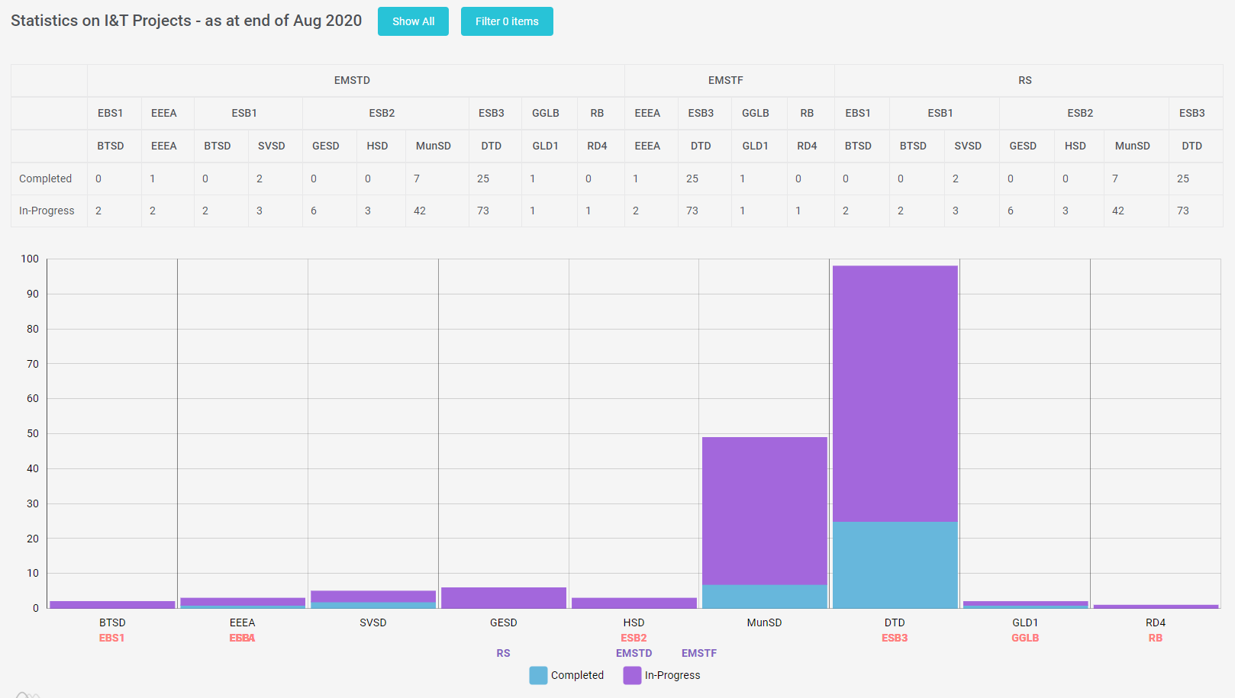

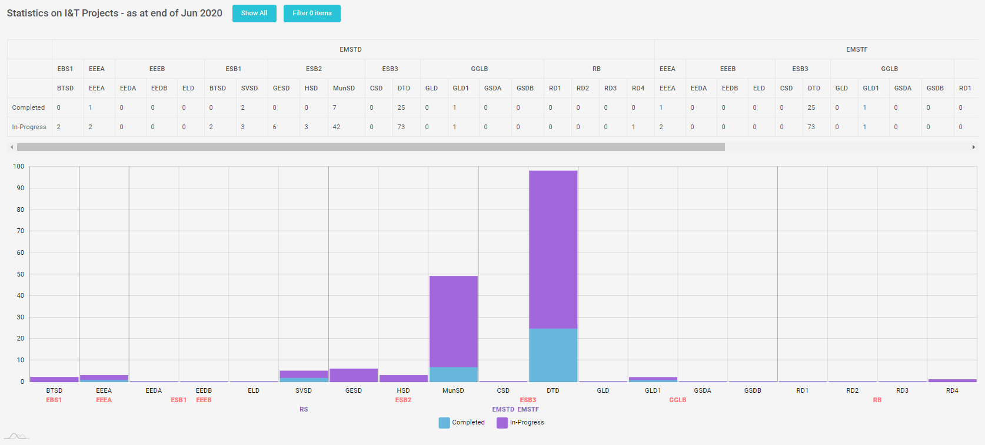

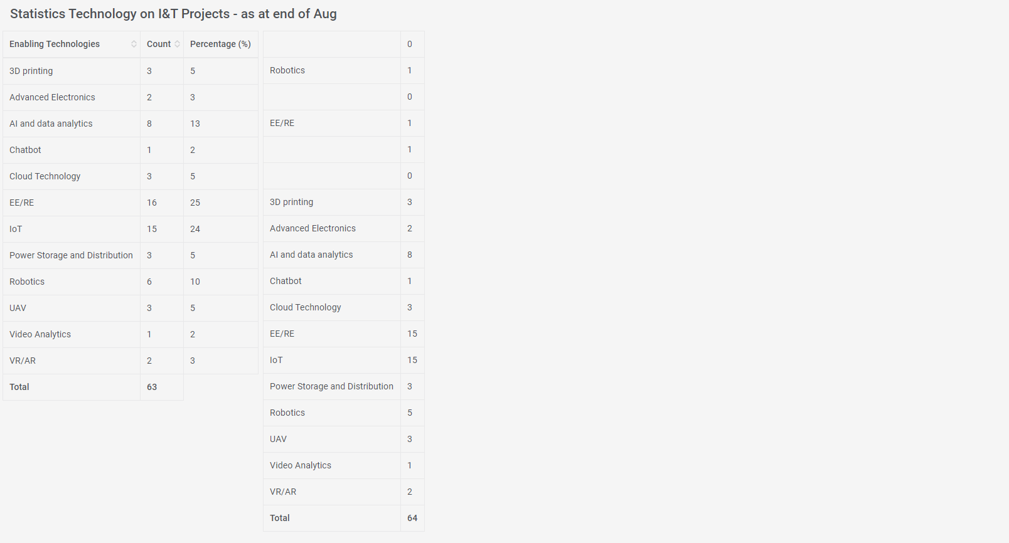

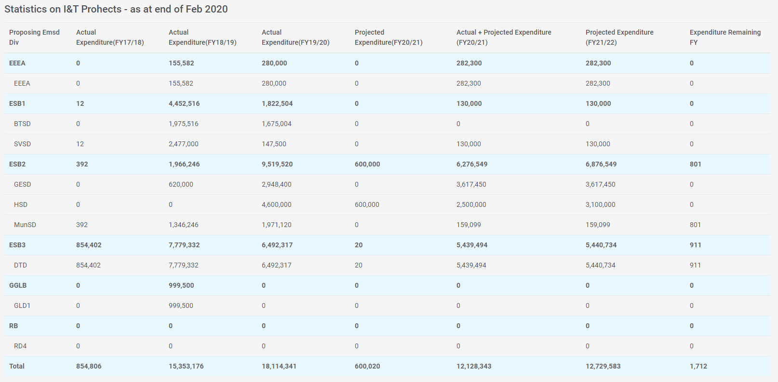

1. Wish Management

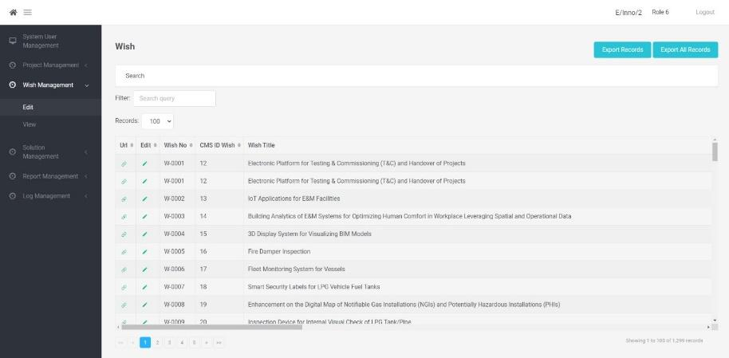

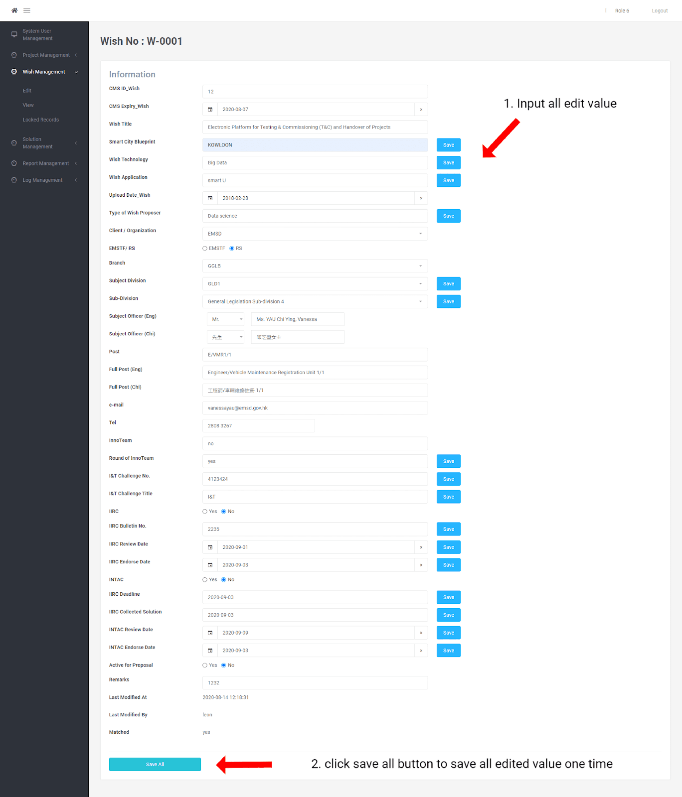

1. Solution Management

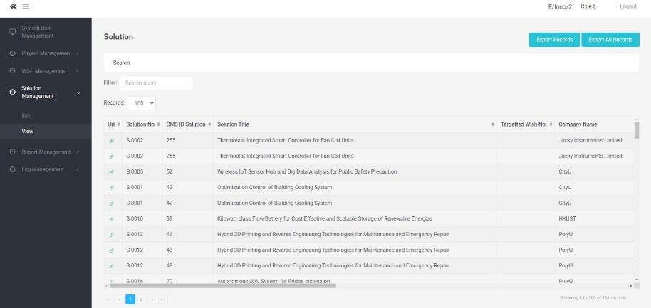

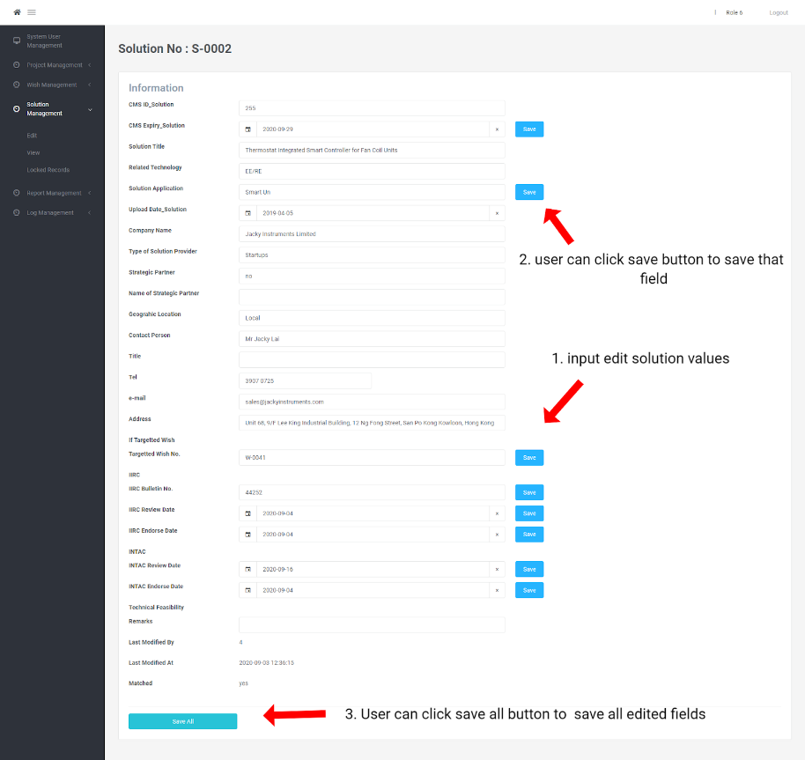

1. Log Management

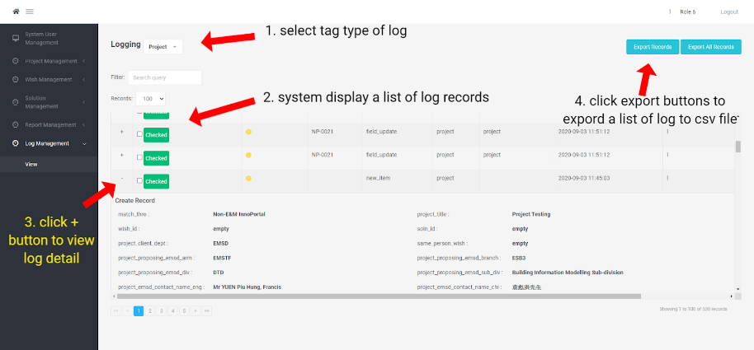

### System Architecture

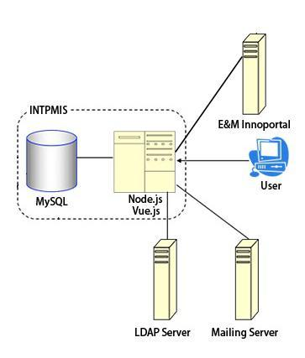

The proposed INTPMIS is a web-based application which is built using Node.js, Vue.js, and MySQL. INTPMIS is designed for bridging the information and collaboration between different users. It interfaces with the online platform E&M InnoPortal to obtain relevant project

data, such as the wish table, project table, and solution table, stored in INTPMIS MySQL database. Users are allowed to fill information and match records via the web user interface which is built by Vue.js. The key features of the system are record searching, record filtering, and report generation.

**Selected Technical System Option**

Node.js and MySQL are applied for the backend of the system when the Vue.js is the frontend of the system.

Node.js is an open source, cross-platform runtime environment for developing server-side and networking applications. Node.js applications are written in JavaScript, and can be run within the Node.js runtime on OS X, Microsoft Windows, and Linux.

Node.js also provides a rich library of various JavaScript modules which simplifies the development of web applications using Node.js to a great extent.

MySQL is an open source relational database management system. It is based on the structure query language (SQL), which is used for adding, removing, and modifying information in the database.

Vue.js is a library for building interactive web interfaces. The goal of Vue.js is to provide the benefits of reactive data binding and composable view components with an API that is as simple as possible.

## Training manual and material

This System Manual intended to provide the necessary information to use the revamped Innoportal, which was launched on 25-8-2020.

The manual assumed that the reader had a good knowledge of Vue, CSS, JAVASCRIPT and Node.js language.

# System & Programming Manual and Workflow

## User Login

The system provide 2 ways to login.

1. SSO login by LDAP API

The SSO login was referred from other existing EMSD system. User will get authentication AD from EMSD Active Directory. And the system will call LDAP API to get users authentication code and information by the staff ID.

2. By user name and password created by admin users.

If user do not have authentication AD, system will redirect users to login page. Users can login to the system by input user name and password.

The following diagram showed the User Authentication workflow:

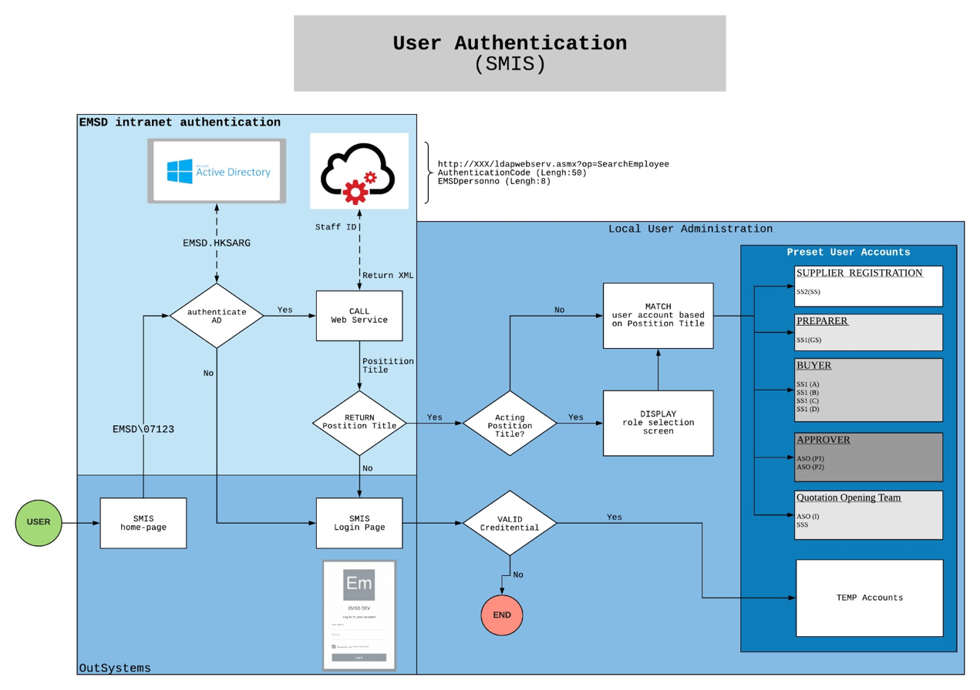

## Database Structure

The system storing all data in eight table in a database. There are include archive, hierarchy, log, project, role, role_user_user_reles, solution, user and wish. All table attribute show as below:

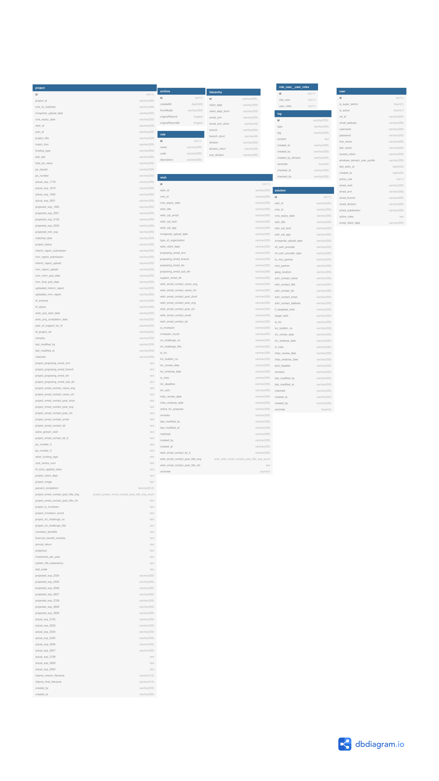

## System structure

| Landing | Landing page calling SSO |
| --- | --- |
| Login | Manual Login page |
| System user management | * 1. Project Management      1. Project Create      2. Projects Edit      3. Project Detail Edit      4. Projects View      5. Project Locked Records   2. Wish Management      1. Wish Edit      2. Wish Detail Edit      3. Wish View      4. Wish Locked Record   3. Solution Management      1. Solution Edit      2. Solution Detail Edit      3. Solution View      4. Solution Locked Record   4. Report Management      1. Report Edit |
| Report View | Report browsing and printing |
| Log Management | Log data |

## Website Layout



After user login, the system would be divides in to three parts Header, Side Menu and Content Component.

## API from innoportal CMS

The system needed to integrate to the InnoPortal CMS by API provided by InnoPortal CMS side. They were list below:

### Solution import

Post <http://intpmis/api/vi/data/import-solution>

Description : This api allow InnoPortal CMS call to import solution

| Key | Type | Required |
| --- | --- | --- |
| **soln_id** | string | true |
| **cms_id** | string | false |
| **cms_expiry_date** | string | false |
| **soln_title** | string | false |
| **soln_cat_tech** | string | false |
| **soln_cat_app** | string | false |
| **innoportal_upload_date** | string | false |
| **int_soln_provider** | string | false |
| **int_soln_provider_type** | string | false |
| **is_moc_partner** | string | false |
| **moc_partner** | string | false |
| **geog_location** | string | false |
| **soln_contact_name** | string | false |
| **soln_contact_title** | string | false |
| **soln_contact_tel** | string | false |
| **soln_contact_email** | string | false |
| **soln_contact_address** | string | false |
| **if_targetted_wish** | string | false |
| **target_wish** | string | false |
| **is_iirc** | string | false |
| **iirc_bulletin_no** | string | false |
| **iirc_review_date** | string | false |
| **iirc_endorse_date** | string | false |
| **is_intac** | string | false |
| **intac_review_date** | string | false |
| **intac_endorse_date** | string | false |
| **tech_feasible** | string | false |
| **remarks** | string | false |
| **last_modified_by** | string | false |
| **last_modified_at** | string | false |
| **matched** | string | false |
| **created_by** | string | false |
| **created_at** | string | false |

Response code :

| Response code | Description |
| --- | --- |
| 200 | Import solution success |
| 400 | Import solution fail |

### Wish import

Post <http://intpmis/api/vi/data/import-wish>

Description : This api allow InnoPortal CMS call to import wish

| Key | Type | Required |
| --- | --- | --- |
| wish_id | string | true |
| cms_id | string | false |
| cms_expiry_date | string | false |
| wish_title | string | false |
| wish_cat_smart | string | false |
| wish_cat_tech | string | false |
| wish_cat_app | string | false |
| innoportal_upload_date | string | false |
| type_of_organization | string | false |
| wish_client_dept | string | false |
| proposing_emsd_arm | string | false |
| proposing_emsd_branch | string | false |
| proposing_emsd_div | string | false |
| proposing_emsd_sub_div | string | false |
| support_emsd_div | string | false |
| wish_emsd_contact_name_eng | string | false |
| wish_emsd_contact_name_chi | string | false |
| wish_emsd_contact_post_short | string | false |
| wish_emsd_contact_post_eng | string | false |
| wish_emsd_contact_post_chi | string | false |
| wish_emsd_contact_email | string | false |
| wish_emsd_contact_tel | string | false |
| is_innoteam | string | false |
| innoteam_round | string | false |
| int_challenge_no | string | false |
| int_challenge_title | string | false |
| is_iirc | string | false |
| iirc_bulletin_no | string | false |
| iirc_review_date | string | false |
| iirc_endorse_date | string | false |
| is_intac | string | false |
| iirc_deadline | string | false |
| iirc_soln | string | false |
| intac_review_date | string | false |
| intac_endorse_date | string | false |
| active_for_proposal | string | false |
| remarks | string | false |
| last_modified_by | string | false |
| last_modified_at | string | false |
| matched | string | false |
| created_by | string | false |
| created_at | string | false |
| wish_emsd_contact_tel_2 | string | false |
| wish_emsd_contact_post_title_eng | string | false |
| wish_emsd_contact_post_title_chi | string | false |

Response code :

| Response code | Description |
| --- | --- |
| 200 | Import wish success |
| 400 | Import wish fail |

## INTPMIS Report

| View Report | |
| --- | --- |
|  | 1. Click “View” under “Report Managment”  2. Scroll down to view more reports |
| Print Report | |
|  | 1. Select the period of the report  2. Select the other day for the report  3. Click “Confirm” button  4. The report is shown  5. Click “Print” to print all report |

The system containing seven report, the report has different aspect to analysis and show result of pass of the project, wish and solution.

### Trend of I&T Wishes, Solutions, and Matched Trial Projects Report

This report showed all number of the wishes, solution and match report in a month, user can swich the bar of top to control system month for view.



### Summary of I&T Wishes Report

This Report showed number of the wish belong to a division, other type means the wishes are create form the other department out of EMSD.





### Distribution of I&T Solutions by Technology Report

This report grouped and counted number of all technology would be used in the solution





### Cash flow for Matched Trial Projects on E&M InnoPortal Report

This report would be show all division which total cash flow of match projects in a year.



### Statistics on I&T Projects Report

This report grouped all division and counted the project of the division. Also, the project would be divides status of compute or in-progress. There have two buttons of the report, Show All and Filter 0 items button.

Clicked Filter 0 items button, the system only show the division which contain a project.



Clicked Show All button, the system would display all the division which contain a project.



### Statistics Technology on I&T Projects Report

This report would be counted and calculated the percentage of technologies used in the projects.



### Expenditure on I&T Projects Report

This report would be summed the actual expenditure and project expenditure of the projects in the year. Also, it would display expenditure of a division.



# Users Procedures and Operation Manual

## Login to INTPMIS

| SSO login | |
| --- | --- |
| User gets an authentication ID from EMSD Active Directory. Then the system will call LDAP API to get users authentication code and information by the staff ID.  If login is successful, the landing page will be shown.  Otherwise, the user name login page will be shown. | |
| User name login | |
|  | 1. Open a browser (Internet Explorer/ Chrome)  2. Go to http://intpmis/#/login  3. Input email address and password  4. click "Sign In" button |
|  | Case 1: Login successfully  The page is navigated to the landing page |
|  | Case 2: Login fail  The error prompt is shown. |

## Project

### Browsing Project List

| View Project | |
| --- | --- |
|  | 1. Click “View” under “Project Management”  2. Scoll the bottom bar to the right to show the project detail |
| Filter Project | |
|  | 1. Input filter value  2. Select display number of record per page  3. The results are shown |
| Search Project | |
|  | 1. Click search section  2. Select search criteria  3. Select values of criteria  4. Click “Search” button  5. The results are shown |
| Export Project | |
|  | There are two options for exporting project  1. Export searched records   * Click “Export Records” button   2. Export all records   * Click “Export All Records” button   The exported results will be stored in a csv file |

### Create a Project

| Create Project | |
| --- | --- |
|  | Click “Create” under “Project Management" |
|  | 1. Fill the required fields  2. Click “Submit” button |
|  | Case 1: Input field is not filled  The error message is shown under the field |
|  | Case 2: Value is not valid  The error message is shown |
|  | Case 3: Project is created successfully  A successful message is shown with the project number  1. Click “X” to redirect to project view page |

### Edit a Project

| Edit Project | |
| --- | --- |
|  | 1. Click “Edit” under “Project Management”  2. Click edit icon to edit the project |
|  | To edit information of the project, users can:  1. select completed  2. input values  3. empty input  Then click “Save All” button |
|  | Case 1: Invalid input  The alert message is shown |
|  | Case 2: Save successfully  The successful message is shown |

## Wish List

### Browsing Wish List

| View Wish | |
| --- | --- |
|  | 1. Click “View” under “Wish Management”  2. Scroll the bottom bar to right to view detail of the wish |
| Search Wish | |
|  | 1. Click search section  2. Select search criteria  3. Select values of criteria  4. Click “Search” button  5. The results are shown |
| Filter Wish | |
|  | 1. Input filter value  2. Select display number of record per page  3. The results are shown |

| Export Wish | |
| --- | --- |
|  | There are two options for exporting wish  1. Export searched records   * Click “Export Records” button   2. Export all records   * Click “Export All Records” button   The exported results will be stored in a csv file |

### Edit a Wish

| Edit Wish | |
| --- | --- |
|  | 1. Input value to edit  2. Click “Save All” button |
|  | Case 1: Invalid input  An alert message is shown |
|  | Case 2: Wish is edited successfully  An alert message is shown |

## Solution List

### Browsing Solution List

| View Solution | |
| --- | --- |
|  | 1. Click “View” under “Solution  Management”  2. Scroll the bottom bar to right to view detail of the solution |
| Search Solution | |
|  | 1. Click search section  2. Select search criteria  3. Select values of criteria  4. Click “Search” button  5. The results are shown |
| Filter Solution | |
|  | 1. Input filter value  2. Select display number of record per page  3. The results are shown |

| Export Solution | |
| --- | --- |
|  | There are two options for exporting solution  1. Export searched records   * Click “Export Records” button   2. Export all records   * Click “Export All Records” button   The exported results will be stored in a csv file |

### Edit a Solution

| Edit Solution | |
| --- | --- |
|  | 1. Input value to edit  2. Click “Save All” button |
|  | Case 1: Invalid input  An alert message is shown |
|  | Case 2: Solution is edited successfully  An alert message is shown |

# Administrator Procedures and Operation Manual

## Project

### Edit a Project

| Edit Project | |
| --- | --- |
|  | ** Admin (Role 6) allowed edit more different fields, such as Date of Uploading Interim Evaluation Report  To edit information of the project, users can:  1. select completed  2. input values  3. empty input  Then click “Save All” button |

## Log List

### Browsing Log List

| View and Export Log | |
| --- | --- |
|  | 1. Select tag type of log  2. Log records are shown in list  3. Click “+” button to view log detail  4. Click “Export Records” button to export records to a csv file |
| Cancel Reminder | |
|  | There are two options to cancel reminder(s):  1. Click checked button to cancel the reminder of a record  2. Select multiple records and click batch checked to cancel reminder of selected records |

Training courses and user experience session

Program Manual including workflow manual

System manual

User procedures manual

Search Function

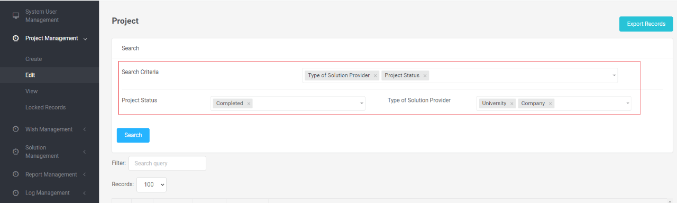

User can search project, wish or solution by used search function. The function allow user to select one or more special search criteria which are fields of the object. After user select criteria, that would be display in below and have all value possible in that fields allow user to search. When user complete the form of search. By click search button, the system would display all object which are satisfy the criteria in below table.

Search Function (report)

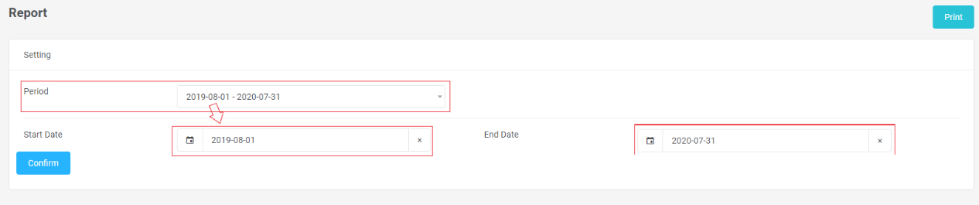

The search function in the report, system allow user selecting a month, then start date and end date would be auto assign in to filed. After click Confirm button, system would be display report to below, that data a during in the selected month.

Export Function

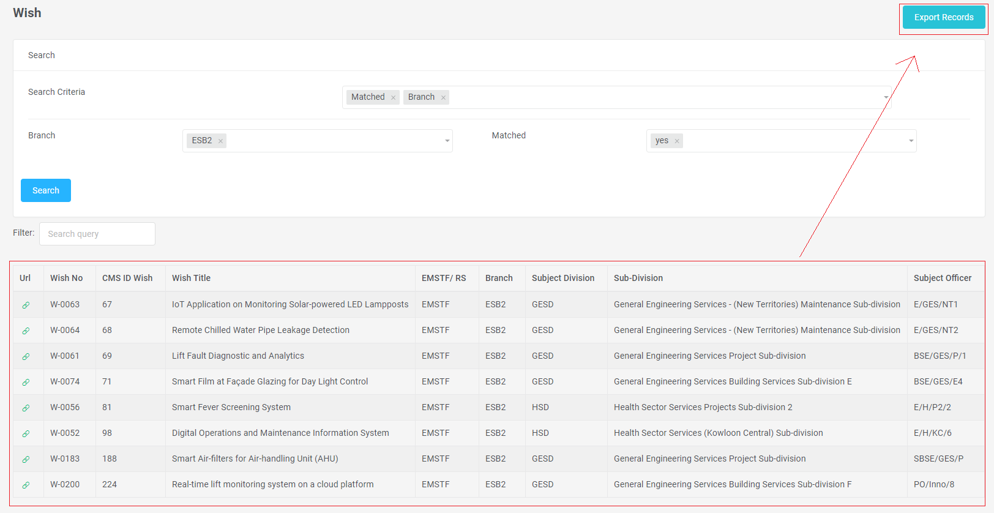

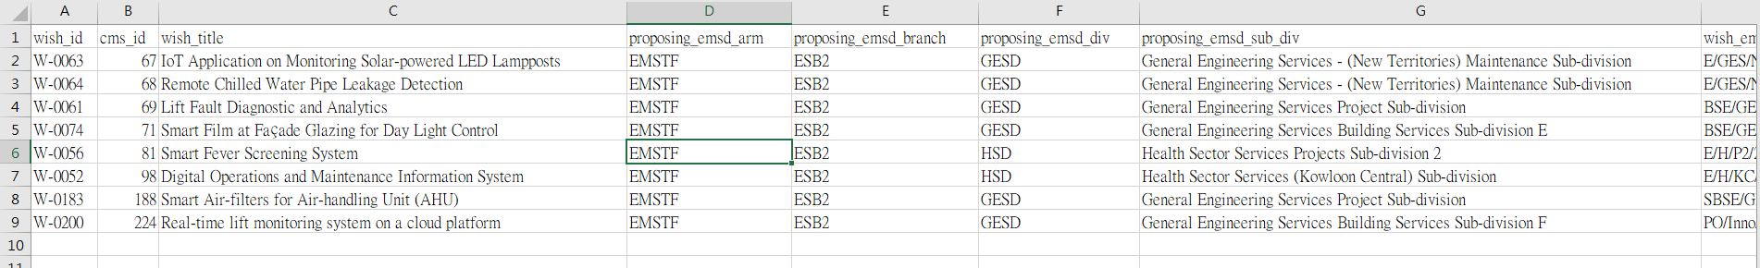

User can export all records after search in the table by clicked Export Records Button. The system would save all records to a csv file to user local file.

Printing Report Function

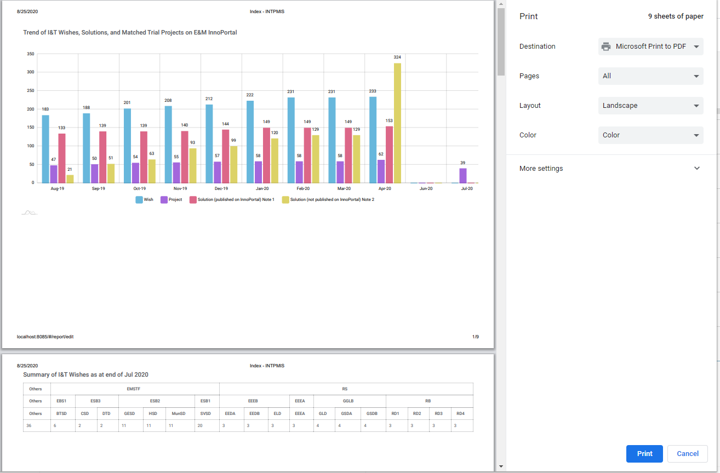

System allow user to printing all report by click the Print button, which in the right side of report search function. Then the system would be pop up a preview page for user adjust the printing setting.

Create Project

| Fields | Input Type | Require | Remark |
| --- | --- | --- | --- |
| Matched Through | select | yes | If user select Non-E&M InnoPortal, Wish No, Solution No, Same Person with Wish Proposer (Y/N) would be hidden |
| Project Title | text | yes |  |
| Project Image | file | yes |  |
| Wish No | number | no |  |
| Solution No | number | no |  |
| Same Person with Wish Proposer (Y/N) | select | no | If click yes in Same Person with wish proposer (Y/N) field, all field in Subject Officer and InnoTeam Related Information auto assign that wish value, exclude InnoTeam (Y/N) field |
| Client Department | select | yes |  |
| EMSTF/ RS | select | yes |  |
| Branch | select | yes |  |
| Division | select | yes |  |
| Sub-Division | select | yes |  |
| Subject Officer (Eng) | text | yes |  |
| Subject Officer (Chi) | text | yes |  |
| Post | text | yes |  |
| Full Post (Eng) | text | yes |  |
| Full Post (Chi) | text | yes |  |
| Email | email | yes |  |
| Tel | number (max 20 digital) | yes |  |
| Tel 2 | number (max 20 digital) | no |  |
| InnoTeam (Y/N) | select | yes | If Click No in InnoTeam (Y/N) field, Round of InnoTeam, InnoTeam Number , InnoTeam Proposal Title would hidden |
| Round of InnoTeam | text | no |  |
| InnoTeam Number | text | no |  |
| InnoTeam Proposal Title | text | no |  |
| Testing Grounds | text | yes |  |
| Trial Scale | text | yes |  |
| Percentage of completion | number | yes |  |
| Monetary benefits | text | no |  |
| Project Status | select | yes | If select Completed of Project Status field, Annual Return, Investment per year, System Life Expectancy fields will be required for create new project |
| Annual Return | number | no |  |
| Investment per year | number | no |  |
| System Life Expectancy | number | no |  |
| Remarks | text | no |  |
| PO issued (Y/NA) | select | yes | User Max can input three PO No. for a project |
| PO No. | number | no |  |
| PO No. 2 | number | no |  |
| PO No. 3 | number | no |  |
| Project Sum(HK$) | number | yes | The Project Sum would be same with sum all expenditure |
| Anticipated/ Actual Contract Start Date | date | yes |  |
| Anticipated/ Actual Contract Completion Date (mm/yyyy) | date | yes |  |
| Actual Expenditure in FY17/18 | number | yes |  |
| Actual Expenditure in FY18/19 | number | yes |  |
| Actual Expenditure in FY19/20 | number | yes |  |
| Actual Expenditure in FY20/21 | number | yes |  |
| Projected Expenditure in FY20/21 | number | yes |  |
| Projected Expenditure in FY21/22 | number | yes |  |
| Projected Expenditure in FY22/23 | number | yes |  |
| Expenditure in Remaining FY(s) | number | yes |  |
| Funding Type | select | yes | If the Funding Type is Cost Center, user new to input cost center number. If the Funding Type is Other, user need to special input the funding type. If the Funding Type is ITF, ITF Scheme Applied, ITF Scheme Status, ITF Project Ref, Year of Support need to input for new project. |
| ITF Scheme Applied | select | no |  |
| ITF Scheme Status | select | no |  |
| ITF Project Ref | text | no |  |
| Year of Support | select | no |  |
| Submission of Interim Report | select | yes |  |
| Submission of MnV Report | select | yes |  |
| Interim Report | file | yes |  |
| MnV Report | file | yes |  |
| Date of uploading Interim Report | date | yes |  |
| Date of uploading MnV Report | date | yes |  |
| Upload of Interim Report | select | yes |  |
| Upload of MnV Report | select | yes |  |
| Funding Type (Others) | text | no |  |
| Cost Center Number | number | no |  |

Administrator Procedures Manual

Logging

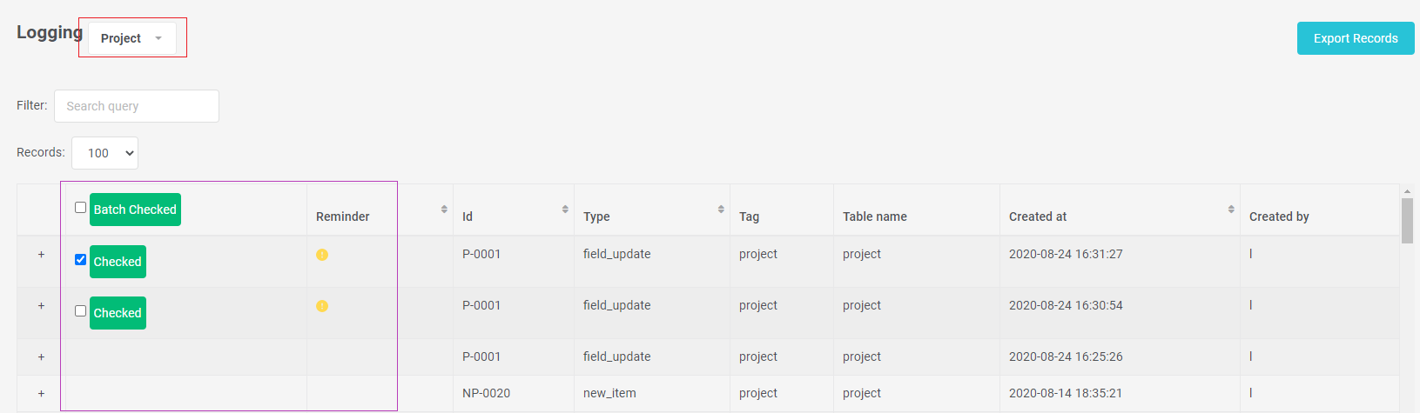

In the logging page. User can check all log record of report, wish or solution. They can select tag he/she wanted to check. After a user create or edit an object, the system would be created log record. In the table all log record would be have a reminder field to remind user that record is new or need to be check. If the user is wants to cancel the remind of a record, he/she can click Checked button in that record, then the system would hidden the reminder of that record. User can also select more than one log records and click Batch Checked button to cancel a list reminder of the records.

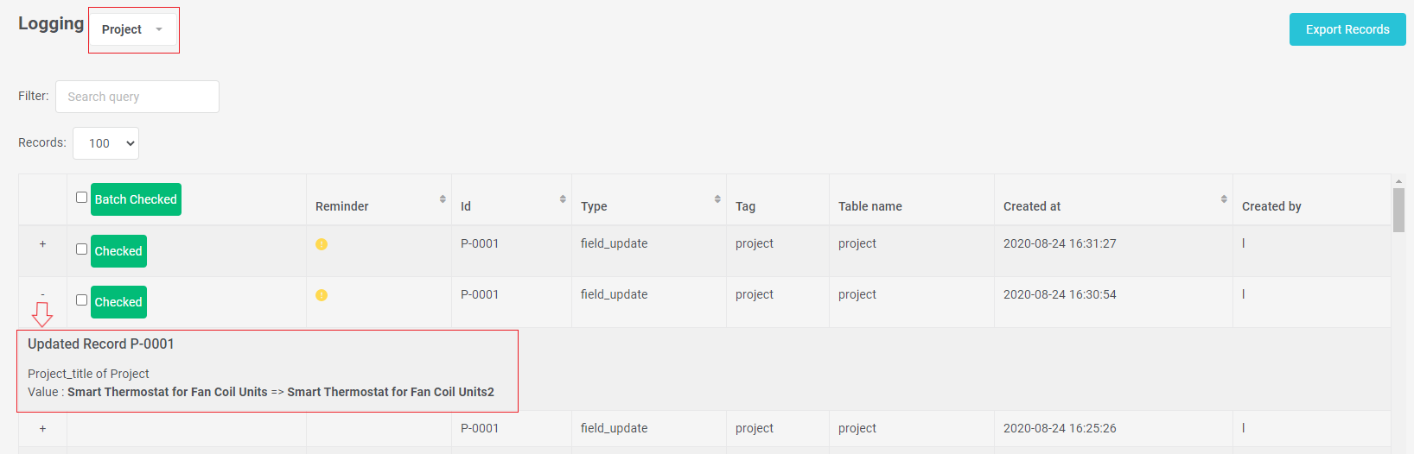User can click + button to checking the detail of the log record. That record would drow down a view to present log detail. Different type of the log would be display different layout of the detail.